Condition number

Function : Reading a Matrix from a File in C

Purpose: This function reads a square matrix of size n x n from a file and stores it in a 2D array (matrix). It is used to load matrix data from external files for computational tasks.

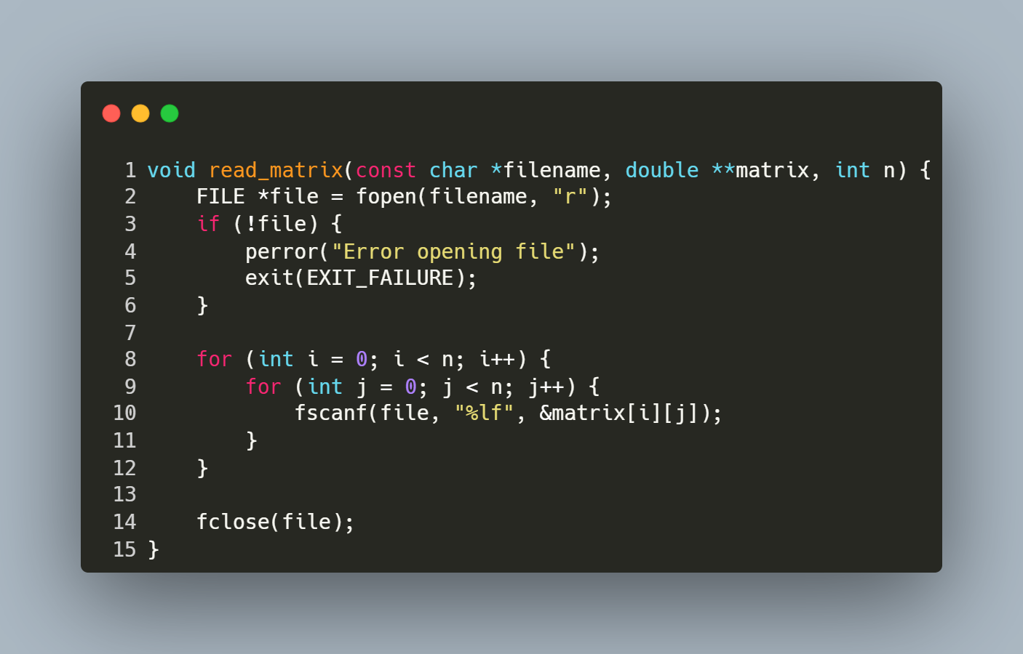
Step-by-Step Explanation
- Opening the File:
  - FILE *file = fopen(filename, "r");
  - Opens the file specified by filename in read mode.
- Error Handling:
  - if (!file) { perror("Error opening file"); exit(EXIT_FAILURE); }
  - Checks if the file was successfully opened. If not, prints an error message and exits the program.
- Reading Matrix Elements:
  - The nested for loops iterate over each row (i) and column (j) of the matrix:
    - fscanf(file, "%lf", &matrix[i][j]);
    - Reads a floating-point number (%lf) from the file and stores it in the corresponding position in the matrix.
- Closing the File:
  - fclose(file);
  - Closes the file after all elements are read to release system resources.

Function: Calculating the Matrix Norm

Purpose: This function calculates the maximum row sum norm (also known as the infinity norm) of a square matrix of size n x n.

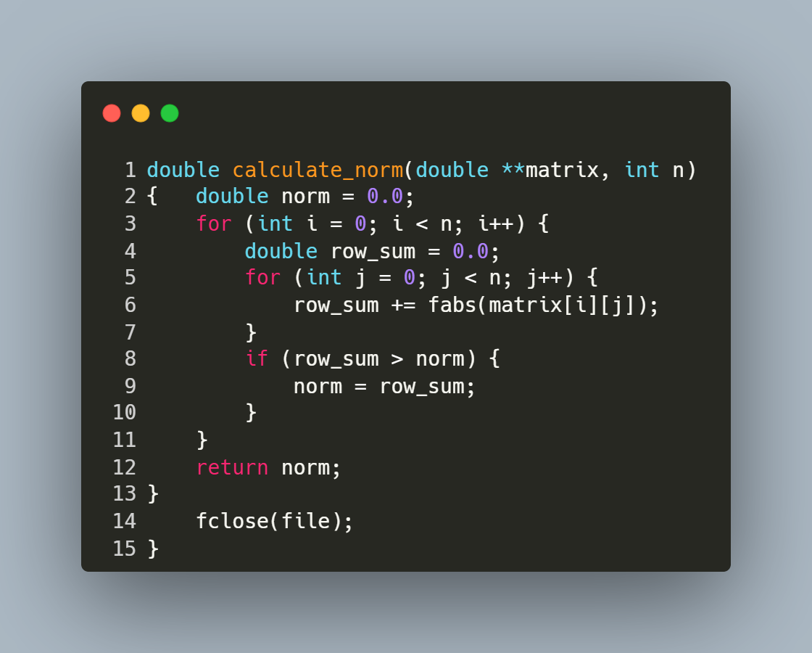
Step-by-Step Explanation
- Initialization:
  - double norm = 0.0;
    - Initializes norm to store the maximum row sum.
- Outer Loop:
  - for (int i = 0; i < n; i++) {
    - Iterates over each row (i) of the matrix.
- Row Sum Calculation:
  - double row_sum = 0.0;
    - Initializes row_sum to accumulate the absolute values of elements in the current row.
- Inner Loop:
  - for (int j = 0; j < n; j++) {
    - Iterates over each column (j) in the current row.
- Absolute Value Addition:
  - row_sum += fabs(matrix[i][j]);
    - Adds the absolute value of each matrix element to row_sum.
- Updating Norm:
  - if (row_sum > norm) { norm = row_sum; }
    - Compares row_sum with norm and updates norm if row_sum is larger.
- Return Statement:
  - return norm;
    - Returns the maximum row sum as the calculated matrix norm.

Recursive Determinant Calculation

Purpose: This function calculates the determinant of a square matrix of size n×n using the cofactor expansion method.
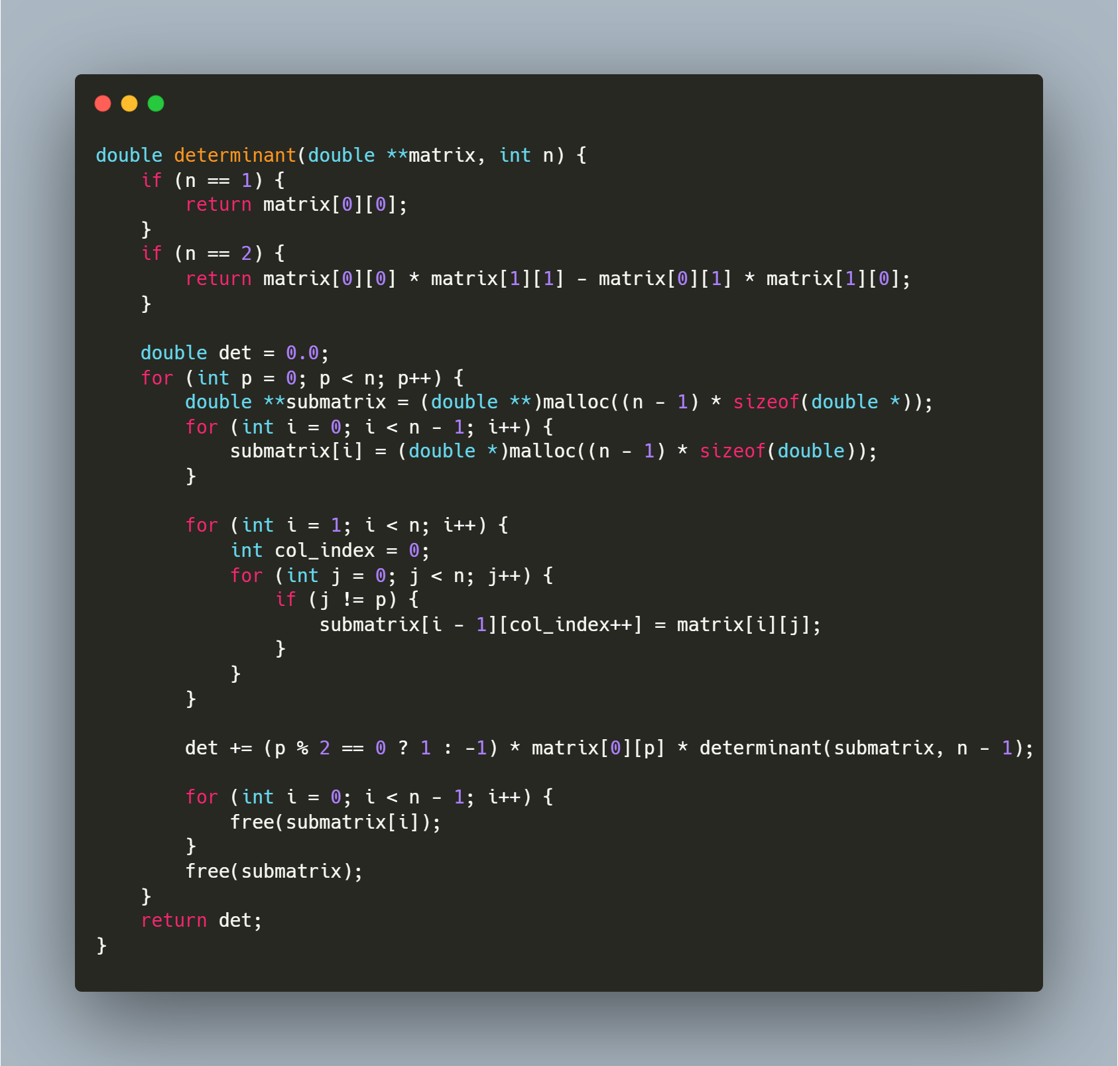
Step-by-Step Explanation
1. Base Cases
- The function handles two base cases for efficiency:
  - 1×1 Matrix: The determinant is simply the single element (matrix).
  - 2×2 Matrix: Uses the direct formula: det([[a,b],[c,d]]) = ad - bc.
2. Cofactor Expansion
For matrices larger than 2×2, the function uses the Laplace expansion along the first row:
double det = 0.0;
for (int p = 0; p < n; p++) {
}
- The variable p iterates through each column of the first row.
- The function will sum up the contributions of each element to the determinant.
3. Submatrix Construction
For each element in the first row, we need a submatrix that excludes the first row and the column containing that element:]
double **submatrix = (double **)malloc((n - 1) * sizeof(double *));
for (int i = 0; i < n - 1; i++) {
submatrix[i] = (double *)malloc((n - 1) * sizeof(double));
}

for (int i = 1; i < n; i++) {
int col_index = 0;
for (int j = 0; j < n; j++) {
if (j != p) {
submatrix[i - 1][col_index++] = matrix[i][j];
}
}
}
- Allocates memory for a submatrix of size (n-1)×(n-1).
- The outer loop starts from row 1 (skipping row 0, which is the first row we're expanding along).
- For each row, we copy elements from the original matrix, skipping the p-th column.
- col_index tracks the position in the submatrix where we're copying elements.
4. Recursive Determinant Calculation
det += (p % 2 == 0 ? 1 : -1) * matrix[0][p] * determinant(submatrix, n - 1);
- This implements the cofactor formula: det(A) =$Σ ((-1)^(i+j) * A[i,j] * det(M[i,j]))$.
- Since we're expanding along the first row (i=0), the sign factor is (-1)^(0+j) or simply (-1)^j.
- (p % 2 == 0 ? 1 : -1) computes (-1)^p, which alternates between 1 and -1.
- The function recursively calls itself to calculate the determinant of the submatrix.
5. Memory Management
for (int i = 0; i < n - 1; i++) {
free(submatrix[i]);
}
free(submatrix);
- Properly frees all dynamically allocated memory to prevent memory leaks.
- Each row of the submatrix is freed individually, then the array of pointers is freed.

Adjoint Matrix Calculation

Purpose: This function calculates the adjoint of a square matrix of size n×n.
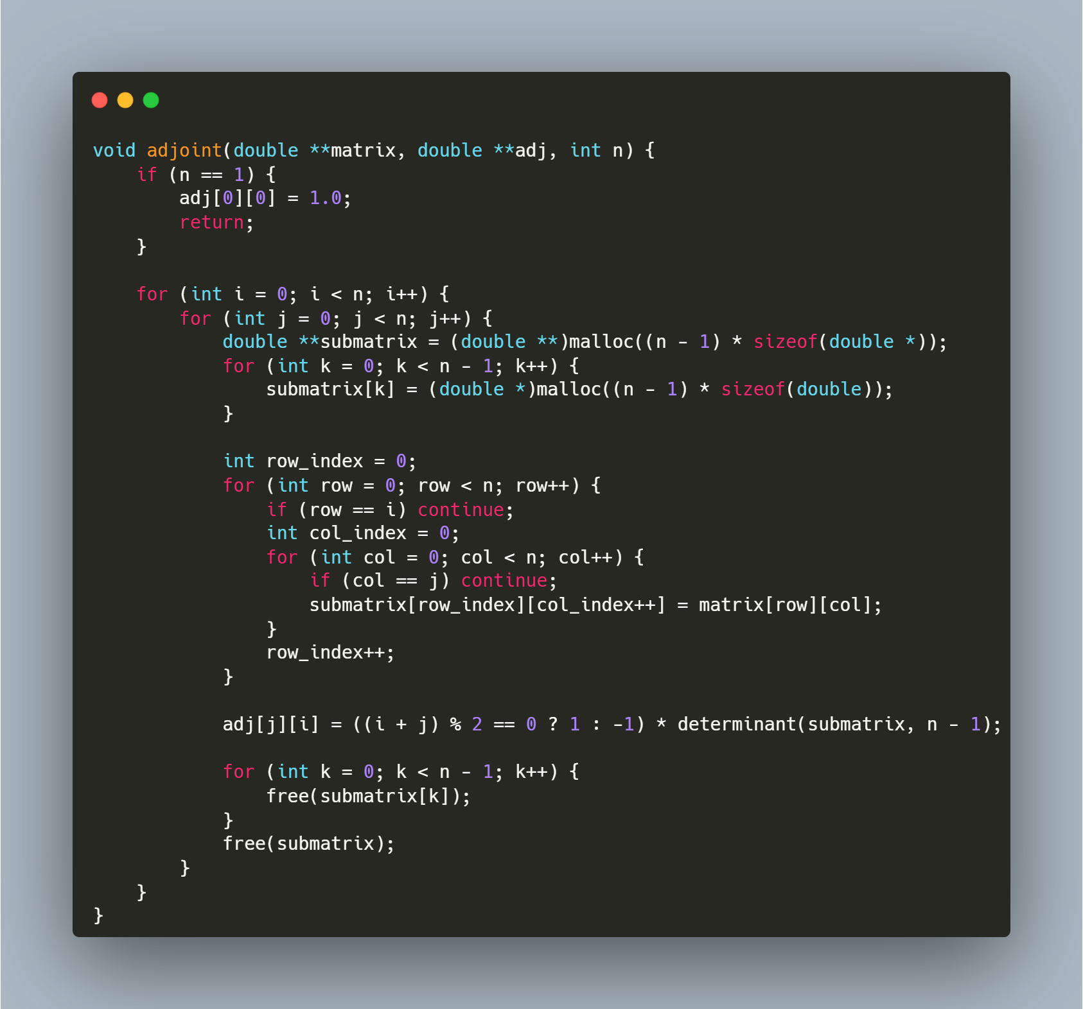

Step-by-Step Explanation
1. Base Case Handling
if (n == 1) {
adj[0][0] = 1.0;
return;
}
- For a 1×1 matrix, the adjoint is simply 1.0
- This is a special case that aligns with the mathematical definition where the adjoint of a 1×1 matrix [a] is1
2. Iterating Through Matrix Elements
for (int i = 0; i < n; i++) {
for (int j = 0; j < n; j++) {
}
}
- The nested loops iterate through each position (i,j) in the original matrix
- For each position, we'll calculate the corresponding cofactor
3. Submatrix Construction
double **submatrix = (double **)malloc((n - 1) * sizeof(double *));
for (int k = 0; k < n - 1; k++) {
submatrix[k] = (double *)malloc((n - 1) * sizeof(double));
}

int row_index = 0;
for (int row = 0; row < n; row++) {
if (row == i) continue;
int col_index = 0;
for (int col = 0; col < n; col++) {
if (col == j) continue;
submatrix[row_index][col_index++] = matrix[row][col];
}
row_index++;
}
- Allocates memory for a submatrix of size (n-1)×(n-1)
- Creates the minor matrix M(i,j) by excluding the i-th row and j-th column from the original matrix
- The row_index and col_index variables track positions in the submatrix
- continue statements skip the i-th row and j-th column of the original matrix
4. Cofactor Calculation and Assignment
adj[j][i] = ((i + j) % 2 == 0 ? 1 : -1) * determinant(submatrix, n - 1);
- Calculates the determinant of the submatrix using the previously defined determinant () function
- Applies the cofactor sign pattern: +1 if (i+j) is even, -1 if (i+j) is odd
- Critical detail: Assigns to adj[j][i] not adj[i][j] - this performs the transpose operation, as the adjoint is the transpose of the cofactor matrix
5. Memory Cleanup
for (int k = 0; k < n - 1; k++) {
free(submatrix[k]);
}
free(submatrix);
- Properly frees the dynamically allocated memory for each submatrix
- Prevents memory leaks by first freeing each row, then the array of pointers

Matrix Inversion Using the Classical Adjoint Method

Purpose: This function computes the inverse of a square matrix using the classical formula: A⁻¹ = adj(A)/det(A).
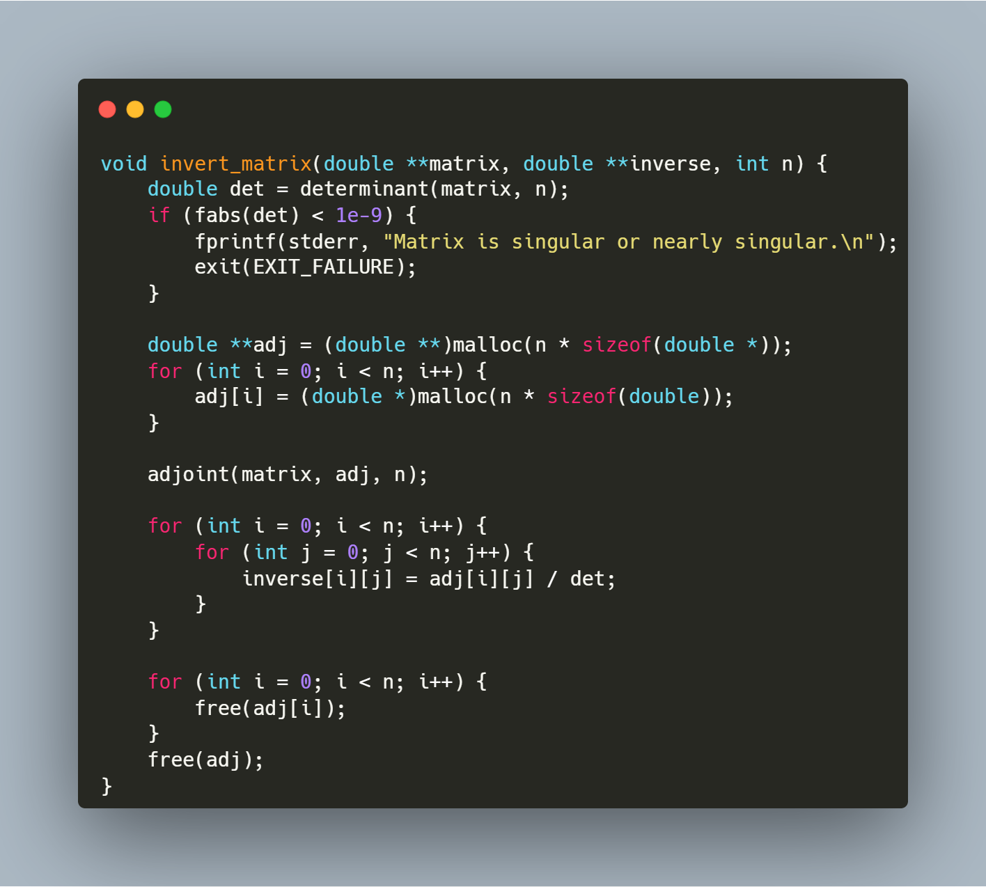
Step-by-Step Explanation
1. Determinant Calculation and Singularity Check
double det = determinant(matrix, n);
if (fabs(det) < 1e-9) {
fprintf(stderr, "Matrix is singular or nearly singular.\n");
exit(EXIT_FAILURE);
}
- Calls the determinant() function to compute the determinant of the input matrix
- Checks if the absolute value of the determinant is less than 10⁻⁹ (effectively zero)
- If the determinant is near zero, the matrix is singular (non-invertible), so the function prints an error message and terminates the program
- This check is critical as divisions by zero (or very small numbers) would lead to numerical instability
2. Memory Allocation for Adjoint Matrix
double **adj = (double **)malloc(n * sizeof(double *));
for (int i = 0; i < n; i++) {
adj[i] = (double *)malloc(n * sizeof(double));
}
- Allocates memory for an n×n matrix to store the adjoint
- Uses a two-dimensional dynamic array structure with row pointers
3. Adjoint Calculation
adjoint(matrix, adj, n);
- Calls the adjoint() function to calculate the adjoint matrix
- The adjoint is the transpose of the cofactor matrix of the original matrix
4. Inverse Calculation
for (int i = 0; i < n; i++) {
for (int j = 0; j < n; j++) {
inverse[i][j] = adj[i][j] / det;
}
}
- Calculates each element of the inverse matrix using the formula: inverse[i][j] = adj[i][j] / det
- Implements the mathematical relationship: A⁻¹ = adj(A)/det(A)
- This nested loop performs n² operations (one division per matrix element)
5. Memory Cleanup
for (int i = 0; i < n; i++) {
free(adj[i]);
}
free(adj);
- Frees all memory allocated for the adjoint matrix
- Prevents memory leaks by first freeing each row, then the array of row pointers

FUNCTION : MAIN PROGRAM FOR MATRIX CONDITION NUMBER CALCULATION

Purpose: This function serves as the main entry point for a program that reads a matrix from a file, calculates its condition, and displays the result. It handles memory allocation, function calls, and memory cleanup.
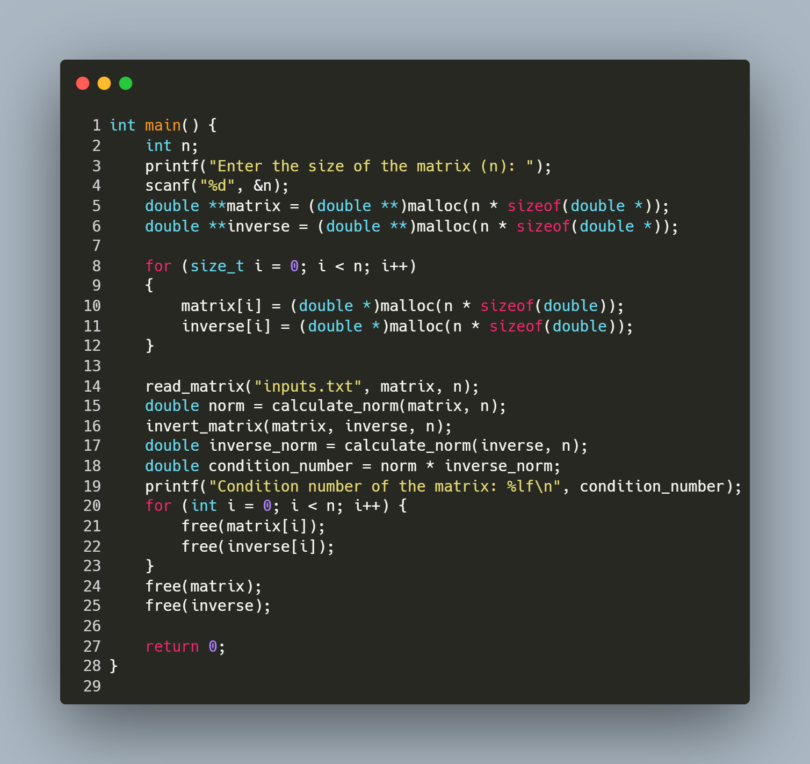
Step-by-Step Explanation:
- User Input:
  - The program prompts the user to enter the size of the square matrix (n).
  - scanf("%d", &n); reads the value entered by the user.
- Memory Allocation:
  - The program allocates memory for two n×n matrices: the original matrix and its inverse.
  - double **matrix = (double **)malloc(n * sizeof(double *)); allocates an array of n pointers.
  - The nested loop allocates memory for each row of both matrices.
- Matrix Reading:
  - read_matrix("inputs.txt", matrix, n); calls the previously defined function to read matrix data from a file.
- Matrix Norm Calculation:
  - double norm = calculate_norm(matrix, n); calculates the norm of the original matrix.
- Matrix Inversion:
  - invert_matrix(matrix, inverse, n); inverts the matrix and stores the result in the inverse array.
- Condition Number Calculation:
  - double inverse_norm = calculate_norm(inverse, n); calculates the norm of the inverse matrix.
  - double condition_number = norm * inverse_norm; computes the condition number as the product of the two norms.
  - The condition number is a measure of how sensitive a matrix is to errors in input data or computational operations.
- Result Output:
  - The program prints the calculated condition number using printf.
- Memory Cleanup:
  - The nested loop frees memory for each row of both matrices.
  - The final two free() calls release the memory for the arrays of pointers.
- Program Termination:
  - return 0; indicates successful program execution.

